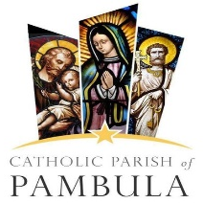

Sunday 7th November, 2021 – 32nd Sunday in Ordinary Time

St Peter’s Catholic Parish
Contact Details
Parish Priest
Fr Paletasala (Pale) Leota
Parish Secretary
Mrs Alicia O’Connor
Parish Council Chair
Mrs Bernadette Wood
Liturgy Coordinator
Ms Sue Heffernan
Finance Chair
Mr Neil Ffrench
Lumen Christi Catholic College
Mr Shane Giles (02) 6495 8888

Marriage Preparations
Damien & Celi Kennedy

Parish Office
Hours - 9:30am to 1:30pm
Wednesday to Friday
Phone - 0435 036 236
Email - pambula@cg.org.au
Web - www.cg.org.au/pambula
Address - 79 Main Street|PO Box 249,
Merimbula, NSW, 2548



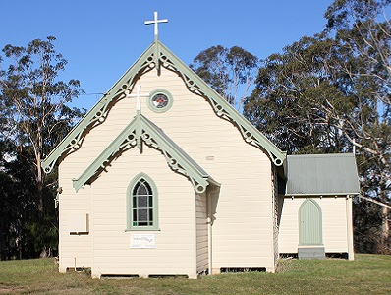

This poor widow has put more in than all who contributed.

Our mission as the Christian community of St Peter’s Parish,
enlightened and inspired by the Holy Spirit,
is to be salt and light through the loving way of our words, actions and respect for the dignity of all, so that others may experience the love of Christ.

We sincerely acknowledge the traditional owners of this land, the Yuin people.

REFLECTION by Fr Michael Tate

The Widow’s Mite

This is the most commonly misunderstood passage in the Gospels. It is usually read in a ‘pat on the back’ tone of voice, commending the widow for her generosity. But it should be read with the tone of white hot anger which Jesus had displayed against the money dealers whom he expelled from the temple only days earlier.
This vulnerable widow was exploited and brainwashed by the scribes and temple authorities so that she gave ‘all she had to live on’. She was left destitute, unable to afford the necessities of life.
On the contrary, Jesus wanted to create a band of followers who would look after widows and orphans. Look at Acts 4:32-37 to see that in operation. In fact, deacons were created in the early Church precisely to care for non-Jewish widows.
The message for the Church from this Gospel story is that it must never exploit the religious fervour of the poor to build up its own resources. Pope Francis is emphasising that the flow must be the other way if we are to be authentic Christians.
We could pause a moment to pray that, imitating the earliest Christian communities, our parish practises true concern for the marginalised and vulnerable, ensuring that they have all the necessities of life in all its dimensions.
© Fr Michael Tate; mtate@bigpond.com

Churches, Mass Celebrations and Prayer ….
Churches  Our Lady Star of the Sea, Eden  St Joseph’s, Merimbula  St Peter’s. Pambula  St Joseph’s, Wyndham  Reconciliation (Confession)  Saturday, 9:30am - 10:00am, Merimbula  Saturday, before Vigil Mass, Eden  Adoration  Every Wednesday at 4:00pm & 1st Friday of the month at 8:30am, Merimbula  1st Sunday at 3:00pm, Eden  Weddings  By appointment only – at least 6 months’ notice in advance. | Mass Times  Saturday, 6pm, Eden  Sunday, 8am & 10am,  Merimbula  Tuesday 5pm, Merimbula  Wednesday, 9:30am, Merimbula  Thursday, 9:30am, Eden  Friday, 9:30am, Merimbula  Sacrament of Baptism  Welcoming Mass – 4th Sat/Sun of the month prior to Baptism. During Mass on 1st Saturday/Sunday of the month. Please ring office for all Baptism preparation enquiries  Divine Mercy Chaplet & Rosary  Tuesdays at 4:30pm,  St Joseph’s Merimbula  November is the month for All Souls
EUCHARISTIC ADORATION
The Lord invites us to take some time out of our busy lives to spend some time with Him in quiet adoration, prayer and reflection.
Every Wednesday at 4pm (Merimbula) & 1st Friday of the month at 8:30am (Merimbula),
1st Sunday at 3pm (Eden).
ALL ARE WELCOME

Feast Days of the Week:
Tuesday 9th- The Dedication of the Lateran Basilica
Wednesday 10th- St Leo the Great (pope, doctor)
Thursday 11th- St Martin of Tours (bishop)
Friday 12th- St Josaphat (bishop, matyr)

PARISH NEWS & EVENTS… Please call 0435 036 236 or email pambula@cg.org.au for any Parish enquiries
BOOK IN FOR MASS: It would be appreciated if you could use the online booking links on the parish website. http://cg.org.au/pambula/Home.aspx
We kindly ask you to arrive early and check in by using the QR code system provided at the entrance to the Church. Those without QR code capabilities can give their name and contact number at the door.

NB: Parish Office will be closed this Friday 5 November.

Volunteers needed!
MAINTENANCE GROUP AT ST JOSEPH’S ~ Volunteers needed to maintain the large grounds surrounding the church. For more information please speak to Father or the office.
CHURCH CLEANING MAINTENANCE ~ Volunteers needed for general maintenance and cleaning duties (2 hours, once a month as per Roster) at St Joseph’s, Merimbula. Kindly contact Chantal Meslin or the Parish Office.

You can still contribute to the cost of building and supporting our beautiful new Sacristy.
Donations can be made into the following account:
BSB: 062-786
ACC: 00030097
Name: St Joseph’s Pambula Sacristy Project
Reference: SURNAME SACRISTY PROJECT
If you prefer to give a cash or cheque donation, please place this in an envelope marked with SACRISTY DONATION and YOUR NAME, and place in the 2nd Collection box.
Thank you!
WALKING TOGETHER ADVENT PROGRAM
Parishes and individuals can now register their interest for the family-themed Walking Together Advent program produced by the local Archdiocese at: bit.ly/WalkingTogether_Advent
The short videos and discussion questions will be available for download week by week starting Sunday 21st November to be used in small discussion groups. Enquiries: lara.kirk@cg.org.au 0429 192 869

AN ORIENTATION DAY REMINDER to all students who have enrolled at Lumen Christi Catholic College for 2022.
KINDERGARTEN 2022
Day 1: Thursday, 2 December 2021 – 9:00am to 11:00am
Day 2: Thursday, 9 December 2021 – 9:00am to 11:00am
Children attend both days and wear comfortable clothes and runners, bring a drink & hat.
YEAR 7 2022
Wednesday, 24 November, 2021 – 9:00am to 3:20pm
Students wear their primary sports uniform and runners. Bring pencil case, recess, lunch, drink & hat.

REMEMBRANCE MASS
This year’s Remembrance Mass will be held at St Joseph’s Merimbula commencing at 9.30am on Friday 5th November 2021. After Mass, you are most welcome to join the families of those parishioners who have passed away in the past 12 months, for a cuppa in the courtyard. Covid-19 restrictions will be in place.

We welcome the newly Baptised
River Vincent Mills
into our Parish Family.
“Enlightened and inspired by the Holy Spirit”
COVID-19 PROTOCOLS AND RESTRICITIONS
"Everyone should look out not only for his own interests, but also for the interests of others.” – Philippians 2:4. As we continue to gather and worship together, it is very important that we be as safe as possible. It is required for all who enter and are in our worship and gathering spaces and parish office for any reason to comply with the recommendations of the COVID 19 Plan and Restrictions.
1. Masks are mandatory, except children under 12.
2. Gatherings are to observe the 4sqm rule.
3. No singing.
4. Service NSW app to be used for COVID Safe Check-in.
5. Parish Offices Open.
6. Mass, Weddings, Funerals: for fully vaccinated and those who are not.
Liturgical Protocols
a. Holy Communion
i. The Body of Christ offered and received, not the Precious Blood.
ii. Received in the hand, not on the tongue.
iii. Sign of Peace – no touching.
b. Music: Permitted and encouraged.
c. Singing: Not permitted.
d. Cash Collections: Encouraged, with touching minimised.
By being safe and respecting others in our community, we are an example of God’s love. We are grateful that our Church – which is God’s house and our home – is an example of our love for one another.

READ THE CATHOLIC VOICE NEWS AT: https://cgcatholic.org.au/
Planned Giving Collections:
First: $550.35; Second: Envelopes $908.00; Loose $181.40
THANK YOU
… to ALL parishioners who continually support our Parish through our plate collections at Mass, through the envelopes and direct banking. Without your financial help our Parish could not continue to function.

The Divine Mercy of Jesus – 3 O’clock Prayer “The Hour of Great Mercy”
Jesus said: Call upon My mercy on behalf of sinners; I desire their salvation. When you say this prayer, with a contrite heart and with faith on behalf of some sinner, I will give that person the grace of conversion. This is the prayer;
“O Blood and Water which gushed forth from the Heart of Jesus as a Fount of Mercy for us, I trust in you.”

Let Us Pray for and support those who are sick and for all who have asked for our prayers.
Maureen Goodman, Michael Sheppard, Anne Bugden, Sandra Bray, Fr John Boyd-Boland ofm, Simplicio Cesar Paul’s Jr, Lydia V. Gaerlan, Chris Greenwood, Margaret Coates, Ron Anderson, Ruth Mercieca, Garry Clear, Anabella Morrell, Michele Cooper, Fraser Cooper, Margaret O’Sullivan, Tina Sio, Patricia Kay, Irene Spinks, Mary Scanlan, Shiela Kebby, Lyn Collie, Geoff Heffernan, Jennifer Wasley, Mary O’Donnell, Judy O’Donnell, John Reynolds, Bill Peterie, , Maureen Andrew, Max Andrew, David Went, Ros Beveridge, Eric Mangion, Mae Hart, Anselmo Guiffre, Beata Denkiewicz, George William Field

We pray for all the Faithful departed or whose anniversaries occur including:
Danielle Louise Sou, Wilfredo A. Riosa, Desmond W. Twigg, Glyneth Middlemiss, Brian Middlemiss, Bernard “Bernie” Cornell, Veronica “Vonnie” Sheetz, Silvia Taglialatel, Errol Cole, John Seberry, Carolynne Picker, Anna Maria Weinlich, Ronald Gaha, Coona Maureen Turner, Stumpy Wallis, Anne Riches, Edwin O’Leary, Brian Kennedy, James Geraghty, “Bill” Raymond William Thornton, Tupa’i Iakopo Nanai, Peter Grubesic, Mary Fenech, Brian Wyndham, Albina Dal Piva, Ruza Novinc, Maureen Partridge, Ken Clear, Millicent Clear, Peter Hamer, John Hulme, Catherine Randazzo, Jeanette Robert, James Barry, Greg Morrison, Glyneth Middlemiss, Brian Middlemiss, Mary D’Arcy, Janine Capell & Winifred Stephenson.

May the souls of the faithful departed, through the mercy of our Lord, Rest in Peace. Amen
May the fullness of peace be theirs in eternal life.
Please advise the Office if you would like to be added to or taken off the list for prayers.

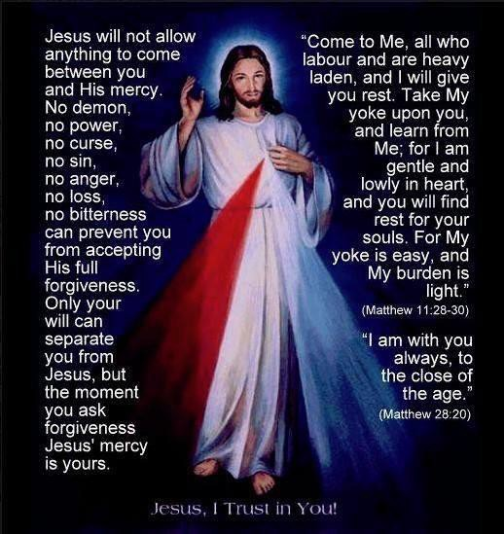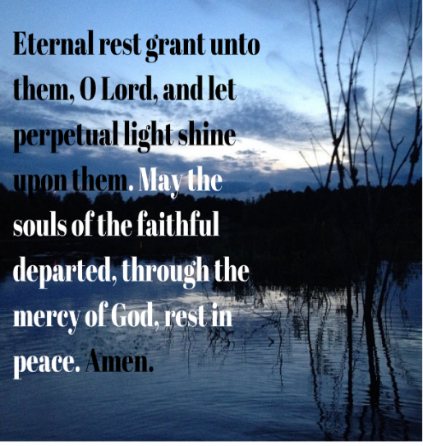
“Enlightened and inspired by the Holy Spirit”

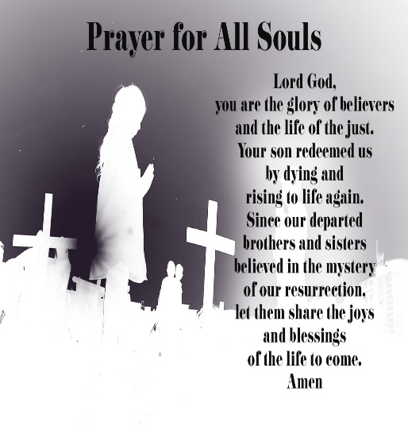
NOVEMBER IS THE MONTH OF ALL SOULS
November is dedicated to praying for the Holy Souls in Purgatory and those that have departed from this life – our family, friends and loved ones. You may like to take additional time this month to pray for the souls, they need our prayers, as they too will pray for us when they reach the eternal life in Heaven.
If you wish to make an Offering in honour of your dearly departed loved one/s, envelopes will be available in the Church.

Sunday’s Gospel and Readings

Second Reading Heb 9:24-28
A reading from the letter to the Hebrews
Christ offered himself only once to take the faults of many on himself.
It is not as though Christ had entered a man-made sanctuary which was only modelled on the real one; but it was heaven itself, so that he could appear in the actual presence of God on our behalf. And he does not have to offer himself again and again, like the high priest going into the sanctuary year after year with the blood that is not his own, or else he would have had to suffer over and over again since the world began. Instead of that, he has made his appearance once and for all, now at the end of the last age, to do away with sin by sacrificing himself. Since men only die once, and after that comes judgement, so Christ, too, offers himself only once to take the faults of many on himself, and when he appears a second time, it will not be to deal with sin but to reward with salvation those who are waiting for him.

Gospel Acclamation Mt 5:3
Alleluia, alleluia! Happy the poor in spirit; the kingdom of heaven is theirs. Alleluia!

Gospel Mk 12:38-44
A reading from the holy Gospel according to Mark
This poor widow has put more in than all who contributed.
In his teaching Jesus said, ‘Beware of the scribes who like to walk about in long robes, to be greeted obsequiously in the market squares, to take the front seats in the synagogues and the places of honour at banquets; these are the men who swallow the property of widows, while making a show of lengthy prayers. The more severe will be the sentence they receive.’
He sat down opposite the treasury and watched the people putting money into the treasury, and many of the rich put in a great deal. A poor widow came and put in two small coins, the equivalent of a penny. Then he called to his disciples and said to them, ‘I tell you solemnly, this poor widow has put more in than all who have contributed to the treasury; for they have all put in money they had over, but she from the little she had has put in everything she possessed, all she had to live on.’

Communion Antiphon Cf. Ps 22:1-2
The Lord is my shepherd; there is nothing I shall want.
Fresh and green are the pastures where he gives me repose, near restful waters he leads me.

N.B. Communion Antiphon is omitted when a hymn is played.
https://www.liturgyhelp.com/calendar/date/2021Nov07/0

Sunday’s Gospel and Readings

Entrance Antiphon Cf. Ps 87:3
Let my prayer come into your presence. Incline your ear to my cry for help, O Lord.

First Reading 1 Kgs 17:10-16
A reading from the first book of the Kings
The widow made a little scone from her flour meal and brought it to Elijah.
Elijah the Prophet went off to Sidon. And when he reached the city gate, there was a widow gathering sticks; addressing her he said, ‘Please bring a little water in a vessel for me to drink.’ She was setting off to bring it when he called after her. ‘Please’ he said, ‘bring me a scrap of bread in your hand.’ ‘As the Lord your God lives’, she replied, ‘I have no baked bread, but only a handful of meal in a jar and a little oil in a jug; I am just gathering a stick or two to go and prepare this for myself and my son to eat, and then we shall die.’ But Elijah said to her, ‘Do not be afraid, go and do as you have said; but first make a little scone of it for me and bring it to me, and then make some for yourself and for your son. For thus the Lord speaks, the God of Israel:
“Jar of meal shall not be spent, jug of oil shall not be emptied, before the day when the Lord sends rain on the face of the earth.”’
The woman went and did as Elijah told her and they ate the food, she, himself and her son. The jar of meal was not spent nor the jug of oil emptied, just as the Lord had foretold through Elijah.

Responsorial Psalm Ps 145:7-10. R.v.2
Praise the Lord, my soul!
It is the Lord who keeps faith forever who is just to those who are oppressed. It is he who gives bread to the hungry, the Lord who sets prisoners free. (R.)
It is the Lord who gives sight to the blind, who raises up those who are bowed down. It is the Lord who loves the just, the Lord who protects the stranger. (R.)
The Lord upholds the widow and orphan but thwarts the path of the wicked. The Lord will reign for ever, Zion’s God, from age to age. (R.)

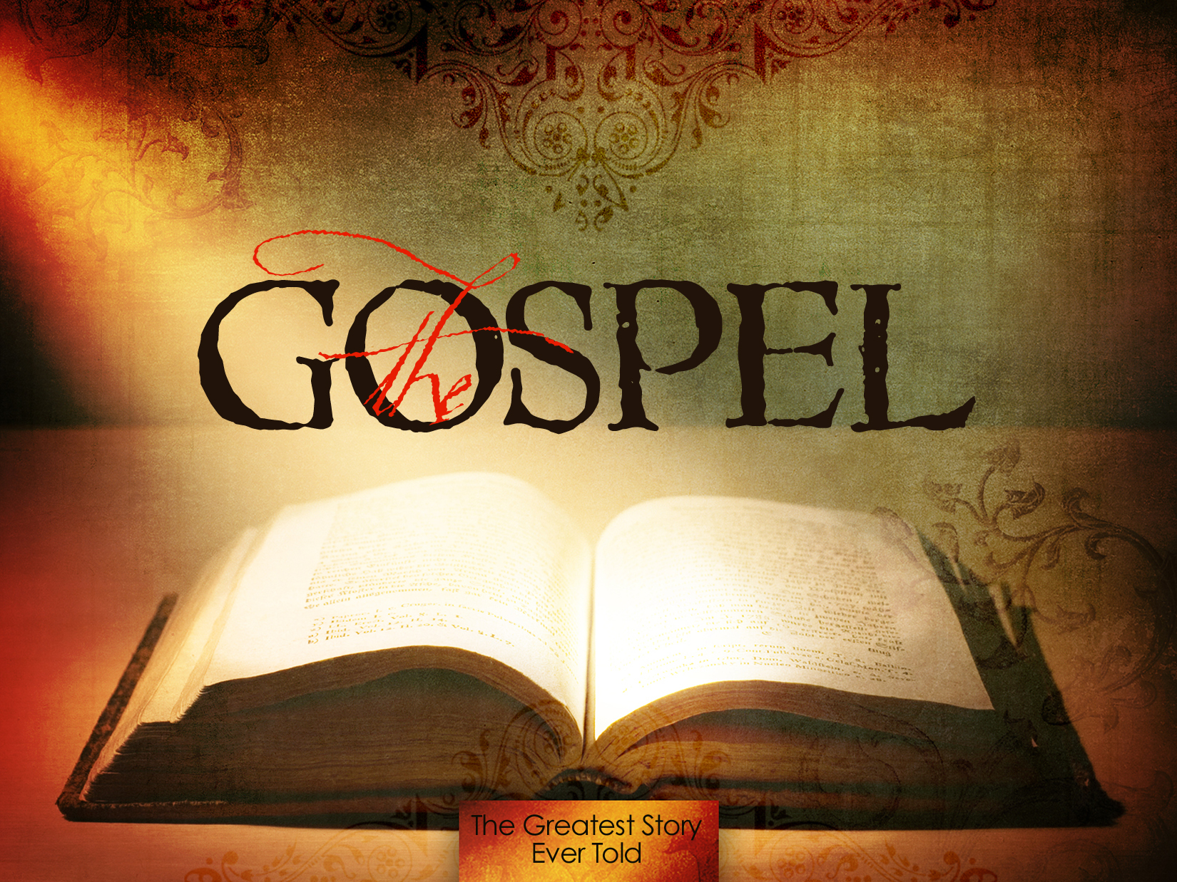
http://www.hines57.com/2016/07/13/the-gospel/
“Enlightened and inspired by the Holy Spirit”

